# C4- S5 - PRACTICE

# Car Inventory Management System

There are many different inventory management techniques that can be used on trucks or materials for either using or selling in a company. For example, Inventory management is used to keep track of the working progress of a variety of data in order to keep a detailed record of goods of seller’s information, product detail , dates of selling , supplier details , cost , quantity of goods.It is not to keep track only of customers ordering products but also to have a good plan for staff to buy products for your store as well to avoid no more products at your store. As a manager you can keep track of all ordering from customers and staff as well.

Think of a database schema of Car Inventory Management System to

manage the sales and production team as inventory management features sample.

**Q1** How many entities should be included in the inventory management system in general? What are they?

**Q2** Identify needed attribute in each entities

**Q3** Design the ERD Physical Model of the Inventory Management System database

**Q4** Implement this database in MySQL

**Q3** Insert below database into the right column in each table.

* store 1 record



* staff 3 records

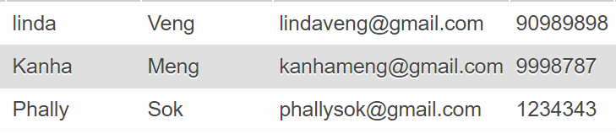

* customers 10 records

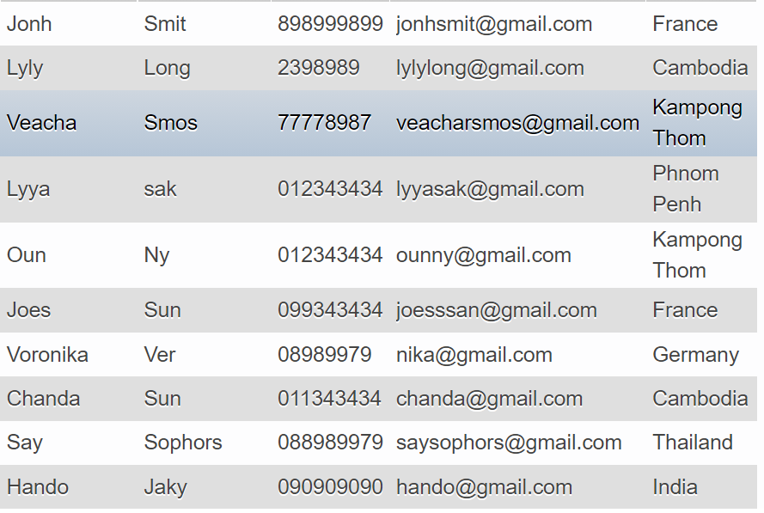

* category 3 records

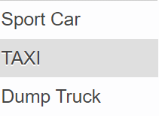

* brand 3 records

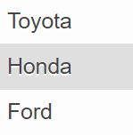

* products 8 records

|  |  |  |  |  |
| --- | --- | --- | --- | --- |
| GR Supra | Toyota | Sport car | 2021 | 45000.00 |
| Dyna FR | Toyota | TAXI | 1990 | 9000.00 |
| Camry | Toyota | Sport car | 2017 | 2000.00 |
| Dyna | Toyota | TAXI | 1990 | 7000.00 |
| Camry | Toyota | Sport car | 2018 | 25000.00 |
| Honda Civic Type R | Honda | Sport car | 2021 | 45000.00 |
| Ford F750 | Ford | Dump Truck | 2000 | 20000.00 |
| ORD TOURNEO | Ford | TAXI | 2021 | 50000.00 |

* orders 10 records

|  |  |  |  |
| --- | --- | --- | --- |
| Jonh Smit | 2021-08-10 | KHMERAUTO | Linda Veng |
| Lyly Long | 2021-07-20 | KHMERAUTO | Kanha Meng |
| Veacha Smos | 2020-08-10 | KHMERAUTO | Kanha Meng |
| Jonh Smit | 2020-08-01 | KHMERAUTO | Phally Sok |
| Lyly Long | 2021-05-10 | KHMERAUTO | Phally Sok |
| Lyly Long | 2020-08-10 | KHMERAUTO | Kanha Meng |
| Veacha Smos | 2020-10-10 | KHMERAUTO | Kanha Meng |
| Jonh Smit | 2021-08-23 | KHMERAUTO | Kanha Meng |
| Jonh Smit | 2021-08-10 | KHMERAUTO | Linda Veng |
| Lyly Long | 2021-07-20 | KHMERAUTO | Kanha Meng |
| Veacha Smos | 2020-08-10 | KHMERAUTO | Kanha Meng |
| Jonh Smit | 2020-03-01 | KHMERAUTO | Phally Sok |
| Lyly Long | 2021-02-10 | KHMERAUTO | Phally Sok |
| Lyly Long | 2020-01-10 | KHMERAUTO | Kanha Meng |

* orderdetails 5 records

|  |  |  |
| --- | --- | --- |
| 5 | Honda Civic Type R | 4 |
| 10 | Honda Civic Type R | 4 |
| 4 | ORD TOURNEO | 2 |
| 9 | ORD TOURNEO | 2 |
| 3 | Camry | 5 |
| 8 | Camry | 5 |
| 2 | Dyna FR | 2 |
| 7 | Dyna FR | 2 |
| 1 | GR Supra | 2 |
| 6 | Camry | 2 |

* Stock

|  |  |  |
| --- | --- | --- |
| KHMERAUTO | GR Supra | 20 |
| KHMERAUTO | Dyna FR | 10 |
| KHMERAUTO | Camry | 0 |
| KHMERAUTO | Dyna | 0 |
| KHMERAUTO | Camry | 10 |
| KHMERAUTO | Honda Civic Type R | 10 |
| KHMERAUTO | Ford F750 | 20 |
| KHMERAUTO | ORD TOURNEO | 0 |

**Q4** Write a query to display all products that sold the most.

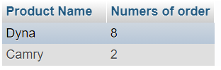

Your query:

**Q5** Display for each customer , how much the customer has spend

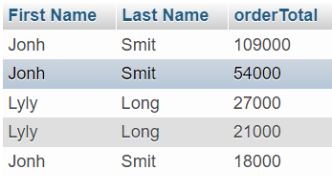

Your query :

**Q6** displays the number of  items in each category.

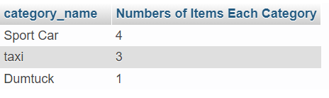

Your query :

**Q7** displays the names of customers who do not buy any products.

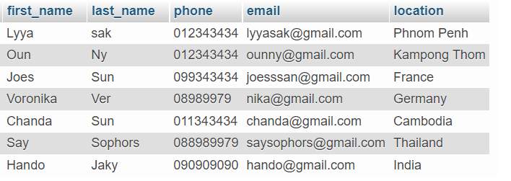

Your query :

**Q8**  display  products that are ordered without duplicate

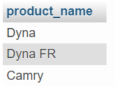

Your query :

**Q9**  Find the products that in the stock more than 10.

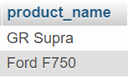

Your query :